CATALOGO CERTIFICATION
HALAL
CERTIFICATION ISO 9001
CERTIFICATION SIF APPROVED CHINA
We export from Brazil to 5 continents, with products Guaranteed by the ISO 9001, BRC - Food products and
HACCP / HACCP
Certification. SGS or BUREAU VERITAS We have approved SIF certify
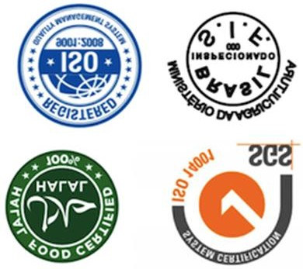

Product Catalogue for Halal Chicken
From Brazil Chicken

CHICKEN PAWS
CIF PRICE U$D 2.820 PER MT

CHICKEN FEETS

CIF PRICE U$D 2,800 PER MT

CHICKEN MID JOINT WINGS

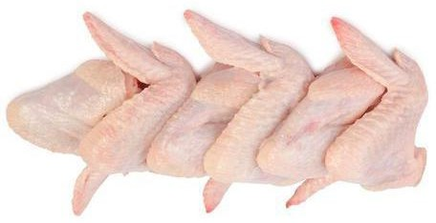
CIF PRICE U$D 2.860 PER MT

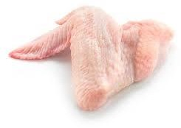
WHOLE JOINT THREE

CIF PRICE U$D 2.860 PER MT

CHICKEN WHOLE LEG
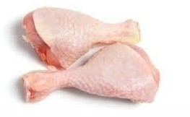
CIF PRICE USD 2.895 PER MT.

WHOLE FROZEN CHICKEN
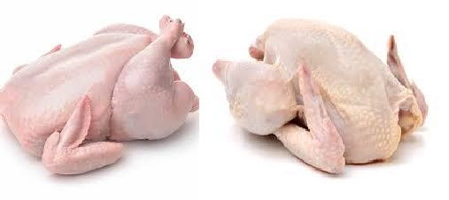
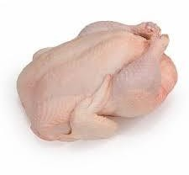
CIF PRICE USD 2.900 PER MT.

CHICKEN LEG QUARTERS

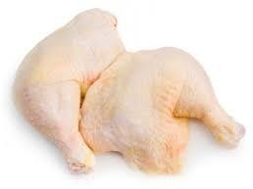
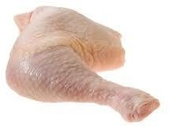
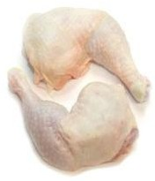

CIF PRICE U$D 2.895 PER MT.
We export from Brazil to 5 continents, with products Guaranteed by the ISO 9001, BRC - Food products and HACCP / HACCP - Critical analysis control HALAL
Certification.
We have approved SIF certifications, to export to CHINA. We are approved to export to the Gulf countries, the Far East, China and also to Turkey and some African countries
FROZEN MEAT: We can export the following products: FROZEN CHICKEN, FROZEN PORK AND FROZEN MEAT
From our SIF approved plants. You will receive our PRODUCT CATALOG AND THE PRODUCT PRICE LIST, to allow you to have brief Information about our Products.
We are available to serve you with your requirements According to your specifications. So that we can send you a quote,
Contact us with your order details, including
- Product confirmation,
- order quantity and
- Your intended port of destination.
This will allow us to come back to you with our current best offers for requested products.
Les-commoditytrading@branex.nl
les-aquariumenergy@branex.nl
info@branex.nl

FULL CORPORATE OFFER (FCO)

TO BRANEX NL INTERNATIONAL
To: Product Name:
Product Specifications and Packaging:
COMMODITY:
ORIGIN: Brazil QUANTITY:
PACKING: 20 kg per carton SHIPPING TERMS: CIF
DESTINATION PORT: Any Port in China PRICE:
(USD): USD $ per ton.
SHIPMENT SIZES: 30 X 40 HQ containers Trial Order first three Months, Then, 50 FCL X 12 Months (EXAMPLE)
INSPECTIONS: SGS at loading Port
PAYMENT TERMS:
20% MT 103 TO THE CONTRACT SIGNED AND RECEIPT OF THE PRO FORMA INVOICE
50% MT 103 ON RECEIPT OF SHIPPING INVOICE COPIES AFTER SUCCESSFUL SHIPPING
30% MT 103 AFTER RECEIVING ALL OTHER SHIPPING DOCUMENTS
ALL PROCEDURES VIA SWIFT TT (MT 103) TO (SELLER'S BANK), BY SWIFT CODE A BE AN EXCLUSIVE APPLICATION
PLEASE NOTE THAT WE ONLY ACCEPT SECOND ORDER CREDIT PAYMENT LETTER
ALL FIRST ORDERS ARE PROCESSED IN THE PAYMENT TERMS BELOW.
L/C 100% CASH BACKED IRREVOCABLE, TRANSFERABLE MT700. LC valid for 45 DAYS.
AGAINST DOCUMENTS AT SIGHT
Packing primary/ secondary:
Primary: Plastic bag properly identified (low density polyethylene) Secondary: Carton sealed with plastic contraction
Date

Packaging:

Free Packaging: Each carton are 4x5 kg LDPE poly bag in 20kg strong carton box with 4 straps out- Side, the carton are over-wrapped with PP film.
Total Net. Weight 27 MT in each 40 feet freezer container with TR Number in each box.
All labelling is in English and Chinese bar coded.

The product shall be packed in a way that guarantees the safety of the chicken packed by the manufacturer according to the specifications.

- Container number
- Container identification
- Gross weight and net weight
- Consignee inspection stamp
- Number of bundles
- Mine brand
Weight & Quality Inspection:
The seller guarantees that each shipment shall be provided with an inspection halal certificate.

Health certificate including weight, quantity and quality at time of loading, and a veterinary certificate.

ROOF OF PRODUCT DOCUMENTS PER LIFT (SHIPMENT)

- Full set, signed, Ocean Bills of Lading marked “FREIGHT PREPAID”, notify and consignee fee, indicating port of loading and port of discharge.

- Packing list and weight list in triplicate to be issued by beneficiary indicating description, detailed specifications, quantity, gross weight, net weight, volume of each carton is required.
- Commercial Invoice.

- Certificate of Weights and Quantity, SGS, Bureau VERITAS or other international standard certification company

- HALAL Certification.
- Phytosanitary Certificate.
- Dioxin Certificate.
- Health Certificate.
- SIF certificate
The inspection in strict accordance with the international chamber of commerce (i.e.) rules.

Contract Procedures
- Buyer sends ICPO to the seller.
- Seller issue FCO in favour of the buyer.
- Buyer signs and return the FCO to the seller within 48 hours.
- Seller issues draft contract/invoice in favour of the buyer for approval.
- Buyer signs and sends back the draft contract/invoice to the seller within 48 hours.
- Within 3 banking days of signing of the final contract, the buyer will Issue LC and send swift copy
to the seller to start shipping process. Validity
It is hereby agreed and understood that this full corporate offer will hold its validity for 5 days.
As the seller as the buyer

Waiting to hear from you soon With Best Regards

